Tamara Kenick
Final Paper
Position Argument – Poverty or Minimum Wage?
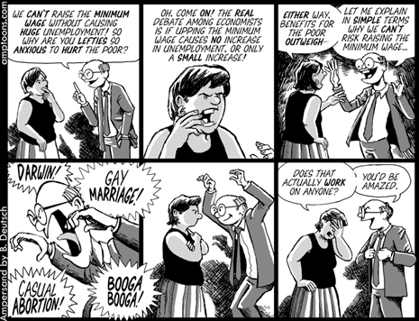
I remember several years ago at the beginning of my career in staffing how much I struggled to make ends meet. I started out at $24k a year as a Staffing Coordinator, was single with a car payment, rent, insurance and various monthly expenses. I knew when starting out that I wasn’t going to make a lot of money. Working full time, I became a bit bitter with how hard I had to work in order to just live. Many weeks at a time I would work 50+ hours in addition to some weekends. But soon I was humbled and my mind changed after I met a struggling family trying to work on minimum wage.
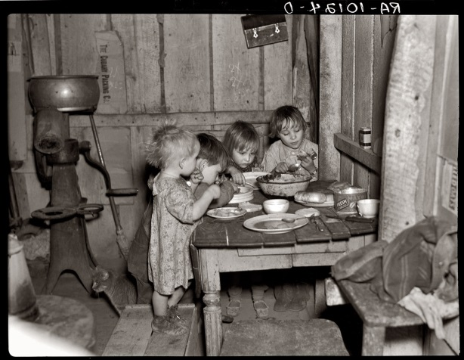
Minimum Wage was set just after the depression when many people were begging for jobs, food and a roof over their heads. In 1938, the Fair Labor Standards Act was signed by President Franklin D. Roosevelt, which covered many labor issues. It not only banned child labor, set the maximum work week to 44 hours but it also set an hourly minimum wage at .25 an hour.¹
In doing research for this paper, I stumbled upon an article and video about how minimum wage is on the decline in the recent years. CNN Money writer Tami Luhby wrote about how according to recent labor statistics, minimum wage is on the decline. I thought how could this be? There are so many people struggling on a monthly basis to just make ends meet. I tried to reason as to why this statistic was true. Was it because more people are unemployed and just not working, or more jobs have higher salaries? I then, read that the study doesn’t include tipped workers, workers such as maids or landscapers who make weekly fixed amounts or people that subsidize their income with federal funds.² The article also had a great short video talking about a couple who struggled with both of them working full time at minimum wages. The two women, one a child care worker and the other a retail worker, struggled on a weekly basis to pay rent, buy food and provide for their three children. I think this demonstrates what the average family has to deal with when making “minimum” or as I call them “poverty” wages. Watch the video here http://money.cnn.com/2013/02/27/news/economy/minimum-wage/index.html

Our staffing firm frequently filled positions in within the general labor industry. Many of our positions paid just above minimum wage which was $5.15/hr. in Utah in 1999.³ Today, it stands at $7.25 an hour and according to President’s Obama’s recent State of the Union Address, should be at $10.55 an hour to accommodate inflation.⁴

Our labor positions frequently paid anywhere between $7-7.50/hr, which many people were jumping at. I had one man come in almost every day to check in to see if we were hiring for labor jobs. Soon, I became very familiar with this man and eventually his family. His name was Manuel and he was married with three small children. He had come to this country a few years earlier, learned English himself and was trying to build a stable income for his family. He lived in a cramped one bedroom apartment with his two cousins, who were also looking for work.
When Manuel brought his children with him into my office, which was frequently, it broke my heart. I could tell they were hot, tired and hungry. I would always get them bottled water and snacks and find paper for them to draw on. They seemed happy for the attention and distraction. I talked to Manuel at length about his struggles to find work. Because he didn’t have a lot of experience and couldn’t operate heavy machinery, many companies overlooked him. Also, his wife was looking for work too but didn’t have a babysitter for the kids, so she had to stay home to care for them. The three guys were on a constant hunt taking day labor or odd jobs where they could, in order to pay their rent, buy gas and food.
Even though they were a family of seven, they could live on very little. Manuel said they could live on $1500/month, which should have been easy for three strong young men to bring in.
But even working odd jobs, most paid just minimum wage, they were only bringing in around $1000/month or less. They never bought clothing; frequently shopped at the dollar stores for supplies and walked anywhere they could, in order to not use their car and waste extra gas.
He even told me several times of being “stiffed” by employers because they felt that he did not do a good job. He never could report it to the authorities because frequently he worked for cash and didn’t want to get in trouble with the police. Even though I knew by this time he wasn’t legal in the country, I wanted to help him, not make his life a greater hell.
Eventually, I was able to send him and his wife and the cousins to work. His wife Isella was able to have a friend watch the children so all four of them could work. Finally, they could bring in enough money to support the family and provide the essentials to live. After I was able to employ them for a long period of time, I could tell the difference in the kids when they came to visit me at the office. They were happy, smiling and lively. They looked like they actually had hope in their eyes. I am not sure if that was truly the case but I knew after this experience, I didn’t complain about my “meager” wages, ever again.
I frequently think of that family and wonder if they ever were able to rise above their struggles and pursue their dreams like I was able to. Personally, after a divorce, bankruptcy and many hard times, I was able to purchase a home, furnishings, car, save for retirement and care for my family. Manuel deserved to make sure that his kids had a greater chance for success than he was given. In the end, I think most of us want not just more money or fancy belongings but a better life for our children.


Works Cited

- Department of Labor Website – FLSA History http://www.dol.gov/oasam/programs/history/flsa1938.htm

- Article by Tami Luhle for CNN Money http://money.cnn.com/2013/02/27/news/economy/minimum-wage/index.html

- taxpolicycenter.org - http://www.taxpolicycenter.org/taxfacts/content/PDF/state_min_wage.pdf

- Article by David Sessions for The Daily Beast – Five things you didn’t know about minimum wage http://www.thedailybeast.com/articles/2013/02/15/five-things-you-didn-t-know-about-the-minimum-wage.html

