Team Meeting #1 Agenda

Task #1

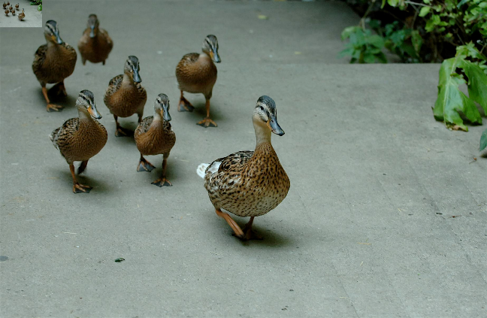
Choose a Task Role and Relationship Roles.
Each member needs to choose a Task Role and a Relationship Role. You need at least these three task roles filled:
- Leader (responsible for getting the team through the agenda)
- Recorder (typing notes from each meeting to send to the instructor)
- Editor (responsible for synthesizing the team’s information for the two paragraphs in the Executive Summary)

This list of team member roles can help the team get started choosing:

Task Roles (Helpful)
- Leader
- Recorder
- Scribe
- Gatekeeper
- Analyzer
- Follower
- Initiator
- Editor
- Information Giver-offers facts, beliefs, input
- Boy Scouter- prepared with map and info
- Information Seeker-asks for clarification, raises helpful questions
- Administrator-keeps people on track, organizes logistics
- Elaborator-offers further clarification
- Clarifier-explains
- Interpreter- make sense of info for group
- Watch Dog- time manager
- Housekeeper- check for loose ends
- Idea Giver -come up with new ideas
- Feedback Giver- reflect, evaluate
- Reminder-er- follow up
- Discusser- discusses things
- Convincer- persuader
- Summarizer-reviews decisions, goals or outcomes
- Decision Maker
- Opinion Giver
- Critiquer-looks at problem from all sides

Task Roles (Not Helpful)
- Dominator
- Blocker- negative resistant behavior, groundless disagreement
- Avoider-noninvolvement, does not contribute ideas or communicate
- Recognition seeker- calls attention to self
- Distractor- goes off on tangents, irrelevant
- Idea Thrower Outer-during brainstorming
- Slider-does little or no work, procrastinates

Relationship Roles (Helpful)
- Harmonizer-helps settle differences
- Sensor-expresses group mood, feelings
- Tension Reliever-creates fun, humor
- Listener-hears content and feeling
- Keep it together-er

Relationship Roles (Not Helpful)
- Clown-distracts from task with self-focused play
- Captain Oblivious- disconnected
- Disconbobulator-keep group in upheaval
- Criticizer-attacks persons not issues

Task #2
Develop 3 or more Relationship Norms.

Task #3

Develop 3 or more Task Norms.

Task #4

Develop 3 Consequences for keeping and 3 consequences for breaking Norms.

Task #5

Choose a Problem (Case Study).
Agree on what Problem your Team wants to solve from the Teamwork Case Studies list provided in the course. You can use can use one of the following methods to make that choice.
- Consensus
- Majority rule
- Minority rule
- Expert rule
- Leader decide

Task #6

Write the Problem as an Open Question.
This is the most important step of the Problem Solving process but most people skip it. The way a problem is defined affects what solutions are possible.

For example, I come into the classroom and there is no podium. I first define the problem thus: Problem: How do we get a podium?

Stated this way there is only one solution—find a podium. However, if you ask me why I need a podium my answer will change the problem and open it up for new solutions. I need the podium to put my notes on. The question then becomes: Problem: How do we find something to put notes on?

There are now many solutions. What could you find in a classroom to solve this problem? Stack up books, turn a garbage can upside-down, get a student to hold them for me… and the list goes on. So don’t write a question that already states your solution.
Poor: How can we make our curfew later?
Good: What is the best way to satisfy our parents’ wish to keep us safe, yet still allow us to attend school play practices at night?

Task #7

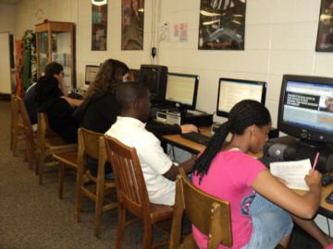
Assign Problem Analysis Areas Research.
Once you’ve defined your problem, you now need to research aspects of the problem so you don’t duplicate mistakes or miss solutions already done.

Each member will research one or more of the areas below and bring the information to your next meeting. Remember to bring your source citations as well.

Problem Analysis Areas
- Characteristics: What are the symptoms of the problem? Include positive as well as negative aspects of the current situation.
- Stakeholders: What groups are affected? How does this problem impact each group? What are each group’s goals?
- History: What solutions have been tried in the past to solve similar problems? How well have these solutions worked? Whom have these solutions helped? Whom have they hindered? How do you know?
- Policies and Politics: What regulations, professional requirements, political considerations, and/or ethical expectations might impact your solution?
- Resources: What references can you consult to get ideas for good solutions? (You are required to use your communication text as one of your references.) Who else can you talk to? How much time and money are you willing to commit?
- Other: Assign other area as needed. Optional

You can look at the Team Meeting 2 Notes Student Example document in the Teamwork Part 2 assignment for an example of what to look for when you research and how to summarize your research.

Task #8

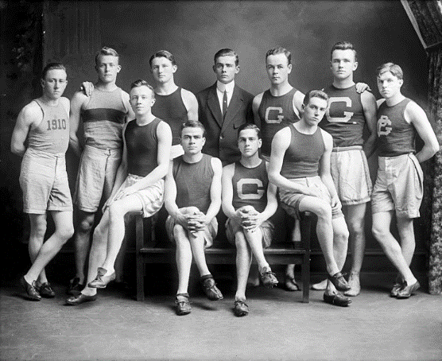
Choose Team Name
Why a name? A team name can bring unity, identity and purpose. For example a football team would likely be called the Eagles rather than the Petticoats. They want to be seen as powerful rather than pretty.

Your team will use the Nominal Group Technique to choose a team name. Brainstorming used to be the method for eliciting multiple solutions but people could not keep the #1 rule for brainstorming to work… don’t criticize the suggestions while in the “brainstorming” stage. Save the critique for the “analysis” stage. The Nominal Group Technique prevents criticism at this key stage.

You can follow these steps to pick a team name.
- Each member, on their own, makes a list of as many names as they can think of.
- Each member shares their list with the team.
- The team as a whole can brainstorm more names by combining names that have been given or thinking of new names.
- The group will “analyze” the names and choose the best one.

Task #9


Plan for Meeting # 2
- Decide when and where your next meeting will be.
- Read instructions for Team Meeting 2 Agenda before the next meeting.
- Agree to come prepared with the material you signed-up to bring. Type your research in essay format so it will be easier for the Recorder to put your research in the meeting notes turned into the instructor.

